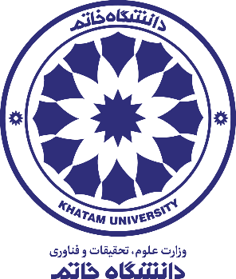

The Faculty of Art and Architecture

**Notice No. 1**

**The criteria and regulations of holding a specialized interview for the doctoral program in the faculty of Art and Architecture at Khatam University in 2023-2024**

All the candidates who have been introduced by the Ministry of Science, Research and Technology to participate in the specialized interview process of the doctoral program in the faculty of Art and Architecture of the university, should submit their application electronically by sending all the documents listed in table number one. The candidates should send these documents to the university to participate in the above-mentioned specialized interview session.

1- The deadline for submitting the documents in physical format is Saturday, June 3rd 2023, 2pm. Considering that the mentioned date cannot be extended, the candidates should take the necessary actions to prepare and send the documents in timely manner.

2- The candidates must carefully complete the form number one attached to this announcement and send it to the university as a request for an interview along with other documents. Documents submitted without the form number one will not be considered.

3- It is worth mentioning that the evaluation of the documents related to the candidate’s execution records which are concerned with the architectural design, having at least two scientific-research articles published in domestic or foreign reputable magazines, conducting an interview in English and presenting a valid English language certificate are the important parts of the research score for the interview of the Doctoral program in the faculty of Art and Architecture.

4- All documents and records should be prepared only in PDF format and in the form of a compact disc (CD) named as described in Table No. 1. It should then be sent to Ms. Meydani with the address of Building No. 2 of Khatam University, East Daneshvar St., Shiraz Shomali St., Tehran, Iran.

5- Failure to comply with the requirements in handing over documents and records to the university is considered as sending distorted documents and such requests will not be processed.

6- The timing schedule of specialized interviews for the PhD program in faculty of Art and Architecture at Khatam University will be announced to the candidates subsequently and in a second notice. Therefore, it is necessary for candidates to regularly follow the announcements issued by the university in this regard through the official website of Khatam University which is “www.khatam.ac.ir”.