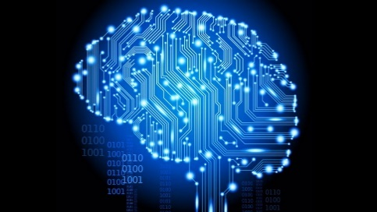

**Second Symposium on**

**Frontiers in Computer and Data Sciences**

**26-27 February, 2025**

**Khatam University, Tehran, Iran**

**Wednesday,** **February, 26**

|  |  |
| --- | --- |
| 08:00-08:45 | On-site Registration & Light Refreshment |
| **Morning Sessions (8:45 to 14:00)** | |
| 08:45-9:00 | Opening |
| 9:00-9:40 | Dr. Shokri – Session 1 |
| 10:00-10:45 | Dr. Seddighin – Session 2 |
| 10:45-11:15 | Coffee Break |
| 11:15-12:00 | Dr.  Najafi – Session 3 |
|  | |
| 12:00 – 14:00 | Lunch Break |
| **Afternoon Sessions (14:00 – 17:00)** | |
| 14:00 – 17:00 | Poster Presentations and Coffee Break |

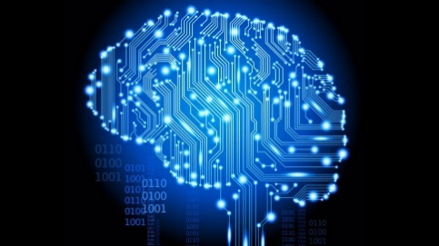

**Second Symposium on**

**Frontiers in Computer and Data Sciences**

**26-27 February, 2025**

**Khatam University, Tehran, Iran**

**Thursday, February, 27**

|  |  |
| --- | --- |
| Morning Sessions (8:00 to 14:00) | |
| 08:00-09:00 | Light Refreshment |
| 09:00-09:45 | Dr. Vondrak – Session 1 |
| 10:00-10:45 | Dr. Salman Beigi – Session 2 |
| 10:45-11:15 | Coffee Break |
| 11:15-12:00 | Dr. Lamirel – Session 3 |
|  | |
| 12:00-14:00 | Lunch Break |
| **Afternoon Sessions (14:00 to 16:30)** | |
| 14:00-14:45 | TBA – Session 4 |
| 15:00-16:00 | Dr. Khalaj & Mr. Saberi -Session 5 |
| 16:00-16:15 | Coffee Break |
| 16:150-17:15 | Final ceremony (with poster awards) |